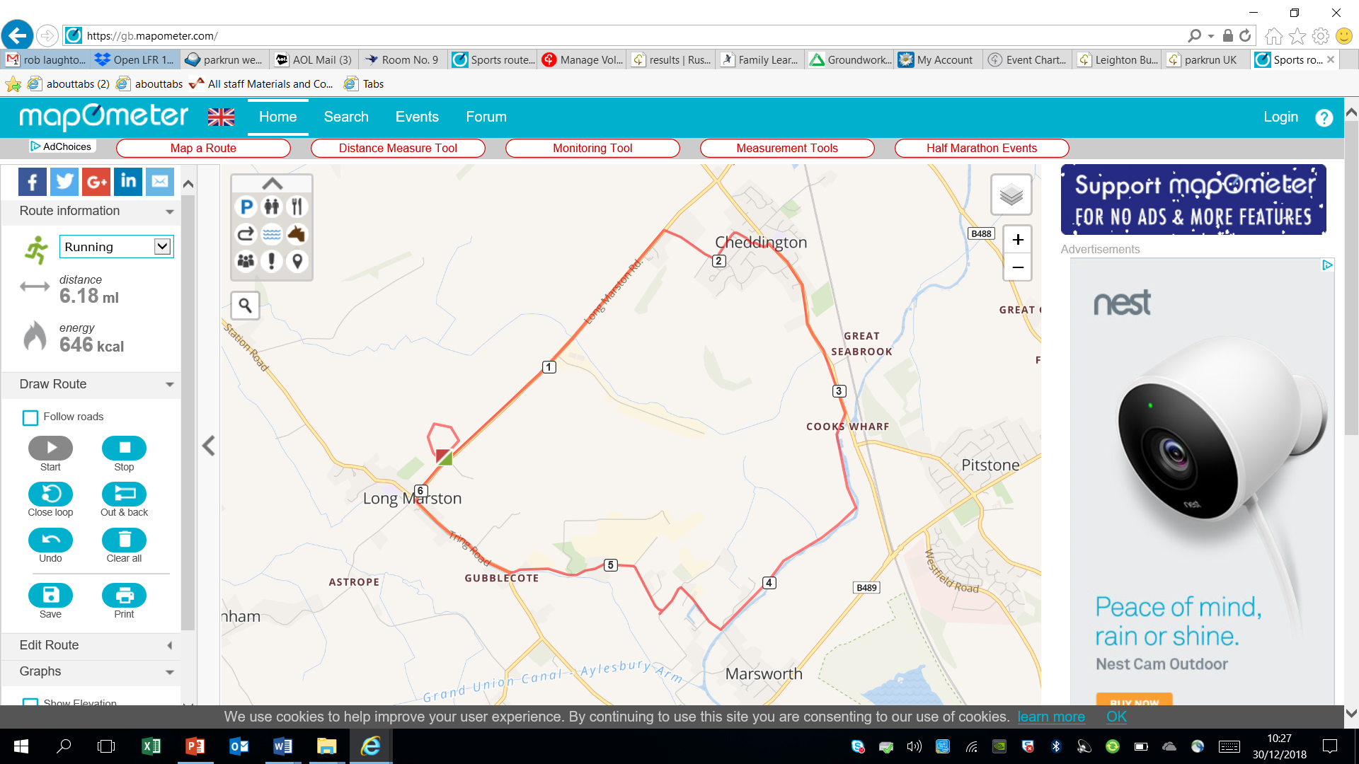

The only race that goes through a pub!!!!