5 Km Coaching

Current situation – typical of club runner
Not a tactical race – running against the clock
Go off hard
Plateau in middle mile
Hanging on for last mile – nothing left.

Thinking about the event
Break it down into 5 sections.
- First 50 mtrs..
- Rest of mile 1
- Mile 2
- Mile 3
- Last 150 mtrs
Plan ahead
Club 5km – know the lay of the land
Billington Hill (2nd half of mile 1)
Mentmore Road (middle of mile 2)
Bridge Street (end of Mile 3)
When to blast for the finish….Post office / park entrance / pencil

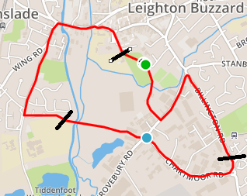

How to train for 5km

Different runs per week
1 –easy run – suggest 5 – 7 miles @ 2mins/miles slower than 5km pace
2 – steady run – suggest 3-5 miles @ 1 min/miles slower than 5km pace
3 – Pace work – suggest 400m-600m sprints with 100m recovery x 6 or 8 times
4 - Every other week – mix in either hill sprints or Fartlek

This could take 6 – 8 weeks of focus if you really want to smash your PB!

